Presents
VINCENT RAMIREZ URBAN TRACKING SEMINAR

APRIL 30 & MAY 1, 2016

I want handlers and their canine companions to experience the positive of tracking. Tracking builds trust in the dog, tracking builds the dog’s confidence and it gives the handler another opportunity to place their hands on the dog with praise. I am comfortable teaching elder retired obedience dogs and young puppies alike. My first tracking dog and I were just looking for something to do after years of obedience. Turbo UD TDX was the perfect instructor passing his TDX just 10 months after his TD at 13.5 years of age. I treasure that time spent working scent with Turbo and have with each dog since. My second tracking dog was started young to become a Champion Tracker June 25, 2000. CT Twister and I stepped away from AKC for the next four years training with USAR NETF-1. With Twister at my side we completed the FEMA USAR Canine Search Specialist Course at Camp Murray, WA September 14, 2001. Training with top SAR handlers and their dogs in difficult if not hostile environments, gave me a welcomed perspective of training in drive and teaching with motivation.

Next were Belgian Tervurens CH CT CoCo Puff, CH OTCH CT Amy and recently CH CT Danya and CH CT Bragger UD. I am currently working two Tervuren in TD/TDX and one Belgian Sheepdog in VST. To date six TD's, seven TDX's, and five VST's / Champion Trackers. I love these dogs and respect their abilities. These titles are theirs not mine.

The TD/TDX method that I use with my dogs is the same that I use for VST. At the seminar I will move quickly from theory, method, and application, hands-on then to debrief questions......... then start the cycle again. We will be back and forth from classroom to field work both days. If one is interested and they pay close attention, they will be offered all that I know pertaining scent, method, application, evaluation, and motivation pertaining to the UTD/UTDX dog. An important part of my seminars is the read and motivation that I learned from my fellow FEMA Canine Search Specialist while training USAR. My method is applied no differently than teaching a competitive obedience dog. By the time that the dog is test ready ....all we are is transportation. Tracking is all about the dog.

The working slots are limited to 20 teams and working participants. A questionnaire will be emailed to all working teams; it is to be returned so that a participant baseline may be established. A participant’s time is shared almost equally between classroom presentation and field work. An emphasis is placed on teaching the canine the required skill sets necessary to title while building the canine’s confidence and motivation. Unlimited auditors and auditors are expected to participate in classroom discussion. You are encouraged to bring a notebook, pen/pencil, a chair, crate, tracking harness, tracking line, tracking articles, training treats, tracking flags. Prepare for weather. Show up with an open mind, negative energy not allowed. ~Vincent Ramirez / Bucyrus, KS

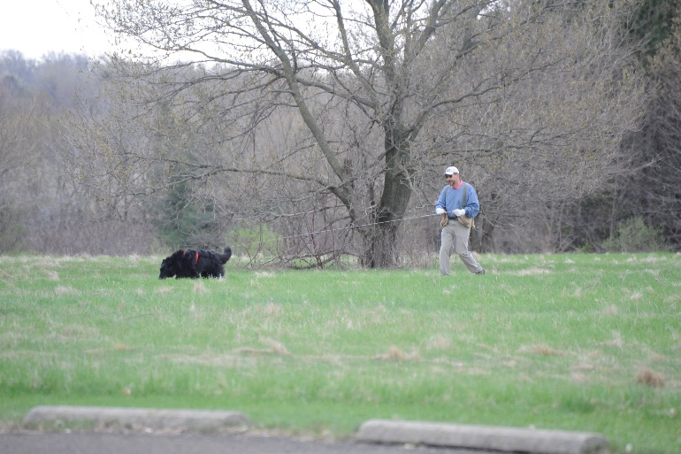

2-Day Working Slot (limited to 20 people | 1 dog per person) = $200 Members/$250 non-club Members ($75 deposit required)
2-Day Auditing Slot (limited to 30 people | no dogs) = $100 ($25 deposit required)

REGISTRATION FORM: VINCENT RAMIREZ URBAN TRACKING SEMINAR
HOSTED BY SCENTRAL ONTARIO TRACKERS IN GUELPH, ONTARIO
APRIL 30 & MAY 1, 2016
Registration will open to Scentral Ontario Trackers Members first and Non-members after February 27-2016. Send your non-refundable deposit ($75 working | $25 auditing) along with the registration form below to reserve your slot or pay in full at time of registration. The remaining fee for your slot must be made by April 1, 2016 to hold your place. Payments for working slots not complete by April 1, 2016 may result in the loss of the slot.
Send form below with cheque made out to Scentral Ontario Trackers and mailed to: Joan Robinson, Box 144, Rockton, ON L0R 1X0 or e-transfer to joan.of.barc@gmail.com or by PayPal on our Club Website at http://scentralontariotrackers.homestead.com/ with a convenience fee of $3 to the total payment when using PayPal.
____________________________________________________________________________________________________________
CANCELLATIONS by April 1: Registration fee minus deposit will be returned. NO REFUNDS AFTER APRIL 1.
Exception: Working slots cancelling at any time will receive a full refund, including deposit, IF there is another team to take their place. Substitutions may be made at any time before the first day of the program. Confirmations will be emailed.

Name _______________________________________________________
Working ____ Auditing ____
Address ______________________________________________________
City __________________________________________
Province __________________
Postal Code________________
Day Phone ________________________ Evening _______________________
Email address _________________________________________________________________
Payment Method and Amount: ____________________________________________________

*Working Spots will receive a questionnaire to complete and return before the seminar.

